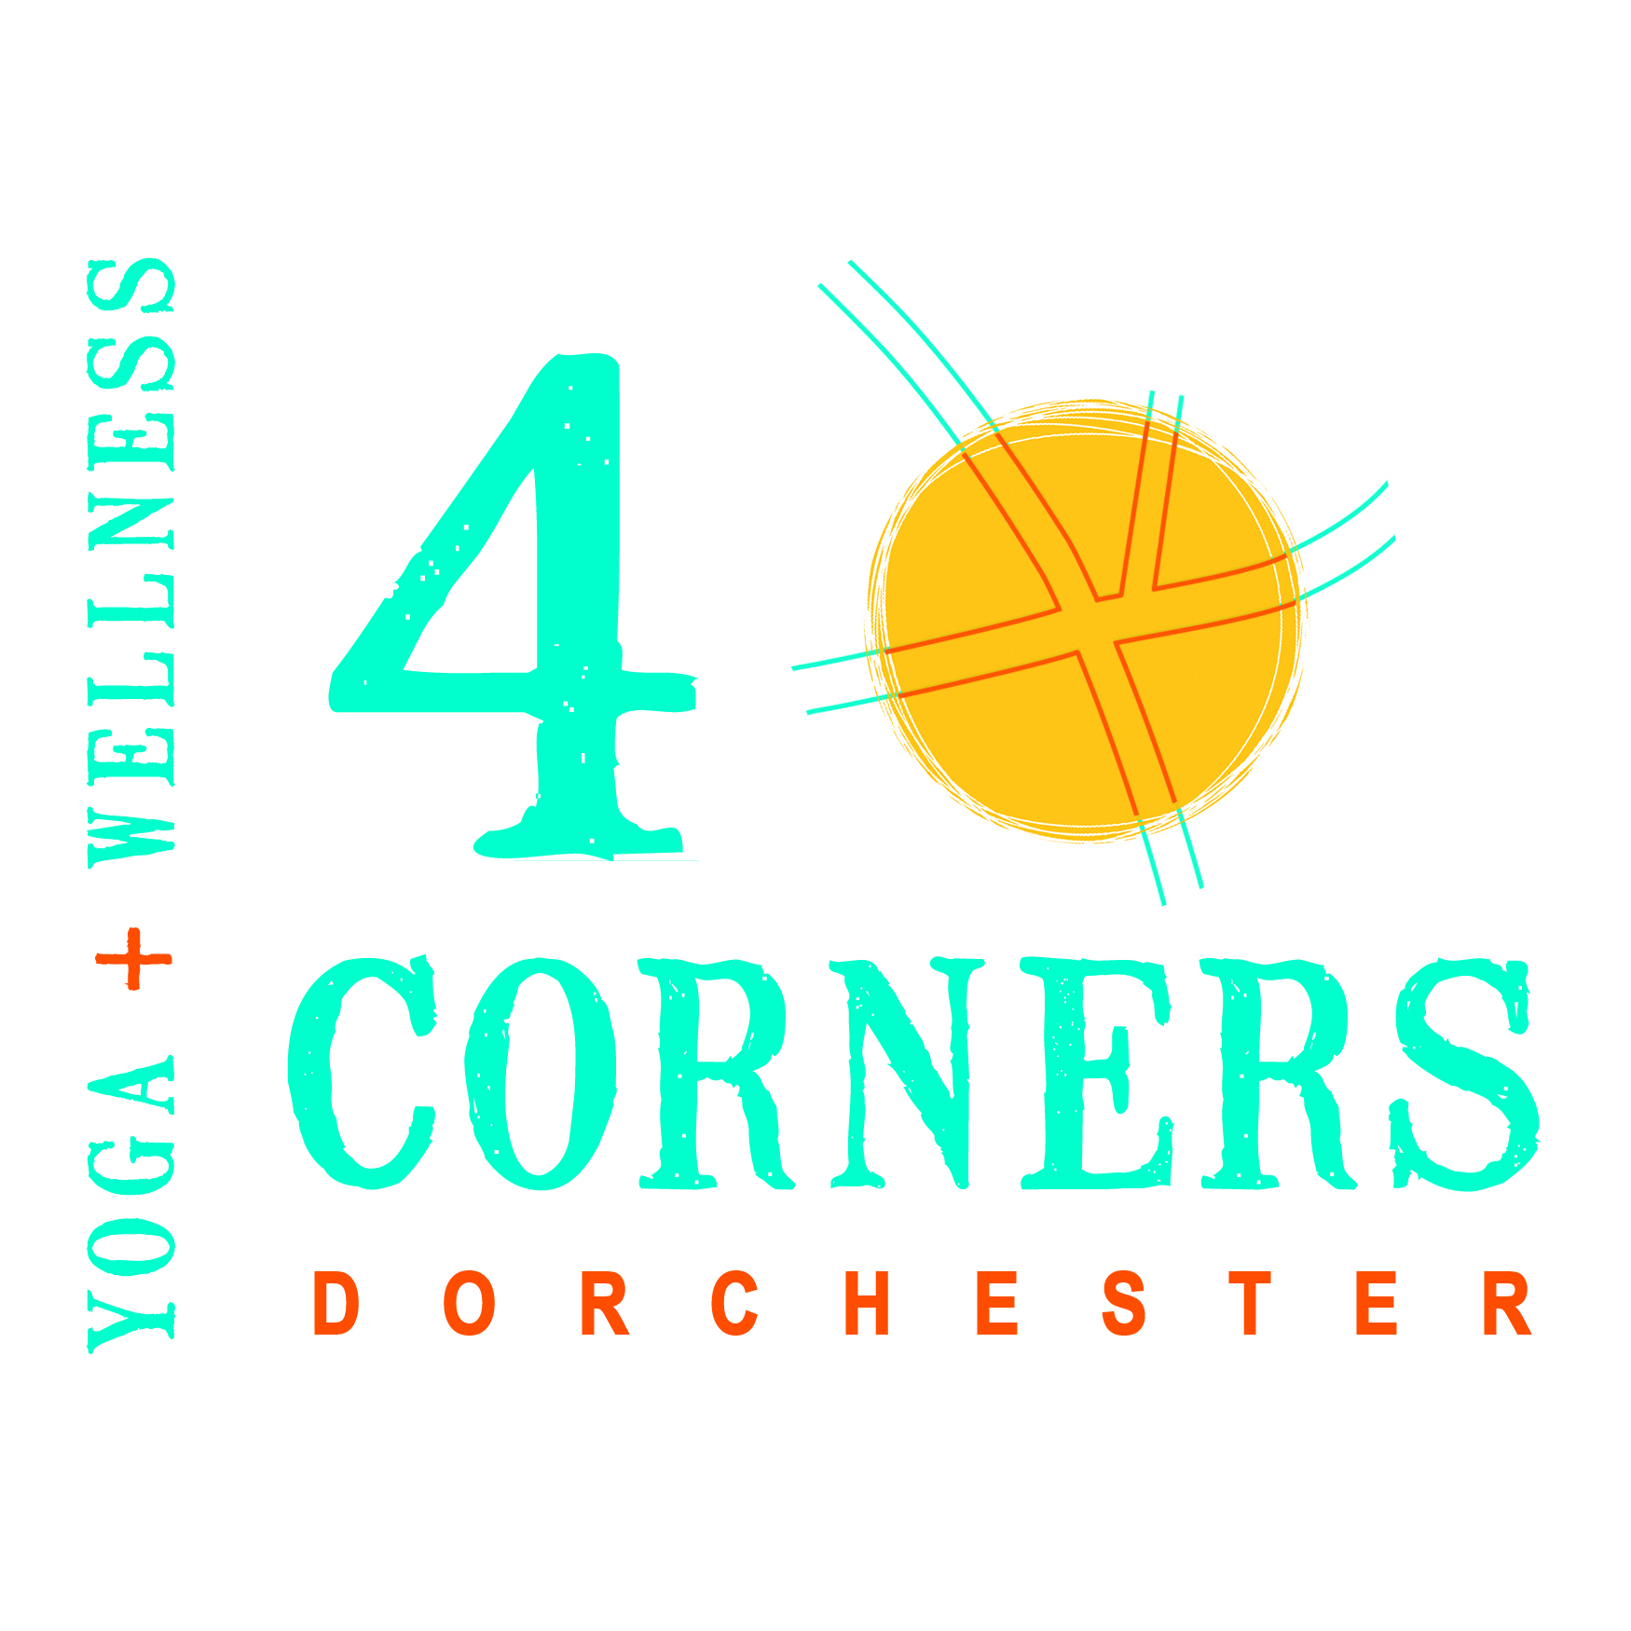
Karuna O’Donnell
co-founder | co-owner
4 Corners Yoga + Wellness
617.435.1749
336 Washington Street
Dorchester, MA 02121
karuna@4cornersyogawellness.com
www.4cornersyogawellness.com
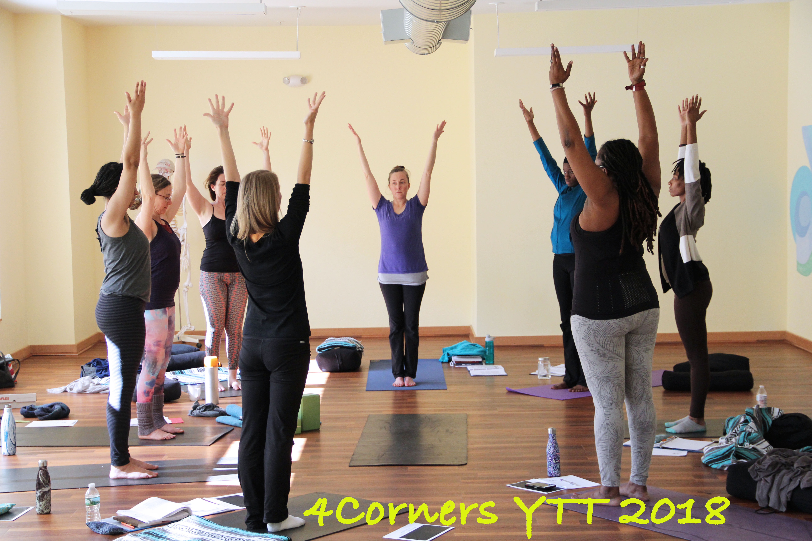
The 4 Corners Yoga School 200-Hour Yoga Teacher Training

We believe that all people are inextricably connected and that your unique contribution is needed for each of us to be whole. Yoga has within it the profound capacity to awaken us to our shared humanity as we discover in ourselves both the seeds of human potential and the seeds of suffering. Yoga provides us with the tools to nourish our unique gifts and address our pain. Yoga as an interpersonal tool is a powerful catalyst for transformation through the interconnected values of service to humanity and the personal practice of yoga. When yoga is accessible, inclusive, and respectful of the diversity and dignity of each student, it becomes a deeper practice; an opportunity for students, through the
explorations of yoga’s life skills and tools for personal well-being, to experience themselves as belonging, worthy and capable of making meaningful contributions for the good of all.
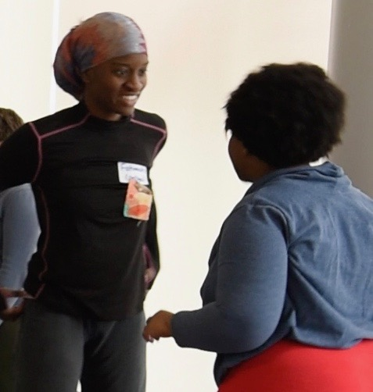

You are eligible to apply if:

• You’ve been practicing yoga for at least one year

• You are ready to immerse yourself in learning and doing yoga

• You want to be an effective and authentic yoga teacher

- You want to be capable of adapting your teaching and using practices designed for community based and non- traditional yoga settings

• You can complete an all levels yoga class (with any and all
modifications!)

After you submit your application, we will review your application. If your application is approved, you will be given a link (and mailing address) to pay either the initial deposit or full tuition. Please note that your space is not reserved until a $500 non-refundable deposit has been made. The remaining tuition must be paid by the first session of the training.

Attendance: 100% attendance required at all sessions.

About the Lead Teacher
Karuna O’Donnell is dedicated to the practice, study and sharing of the competency of yoga as a tool for personal and social transformation. Karuna has been practicing yoga since 1992 and teaching yoga professionally since 2009. Her approach is compassionate, effective and collaborative. She draws directly from her own life experiences, which include years spent living and teaching at yoga ashrams in India and upstate New York, graduate studies in education with a focus on trauma informed care,
a professional background in arts education with complexly traumatized adolescents and adults, years of teaching yoga in addiction
rehabilitation centers and community based settings, and years of personal practice and mentorship with her teachers.

Breakdown of 200 Hours
Nine weekend modules (20 hours per module) = 180 hours
Private mentorship sessions= 2 hours
Weekly yoga classes with 10 written assessments = 45 hours*
Assigned reading and writing = 10 hours
Public service = 10 hours

* The weekly classes are classes of your choice that support your learning interests. Teacher trainees will receive a discount to all classes at 4 Corners Yoga + Wellness.

Early Bird Enrollment
(both acceptance and full payment)
at least one month before first lecture date:
– $2800

Regular Enrollment
(for payment plans and those registering within the month before the first session)
– $3300

A Limited Number of
Scholarships are Available
Please email karuna@4cornersyogawellness.com
Scholarship applications are due by Wednesday July 25, 2018.

Important Note: An additional 3% of the tuition amount will be
charged for payments made with credit or debit card. Paying by check is encouraged.

4 Corners Yoga Teacher Training Application
(Please provide an extra page if you need more space)

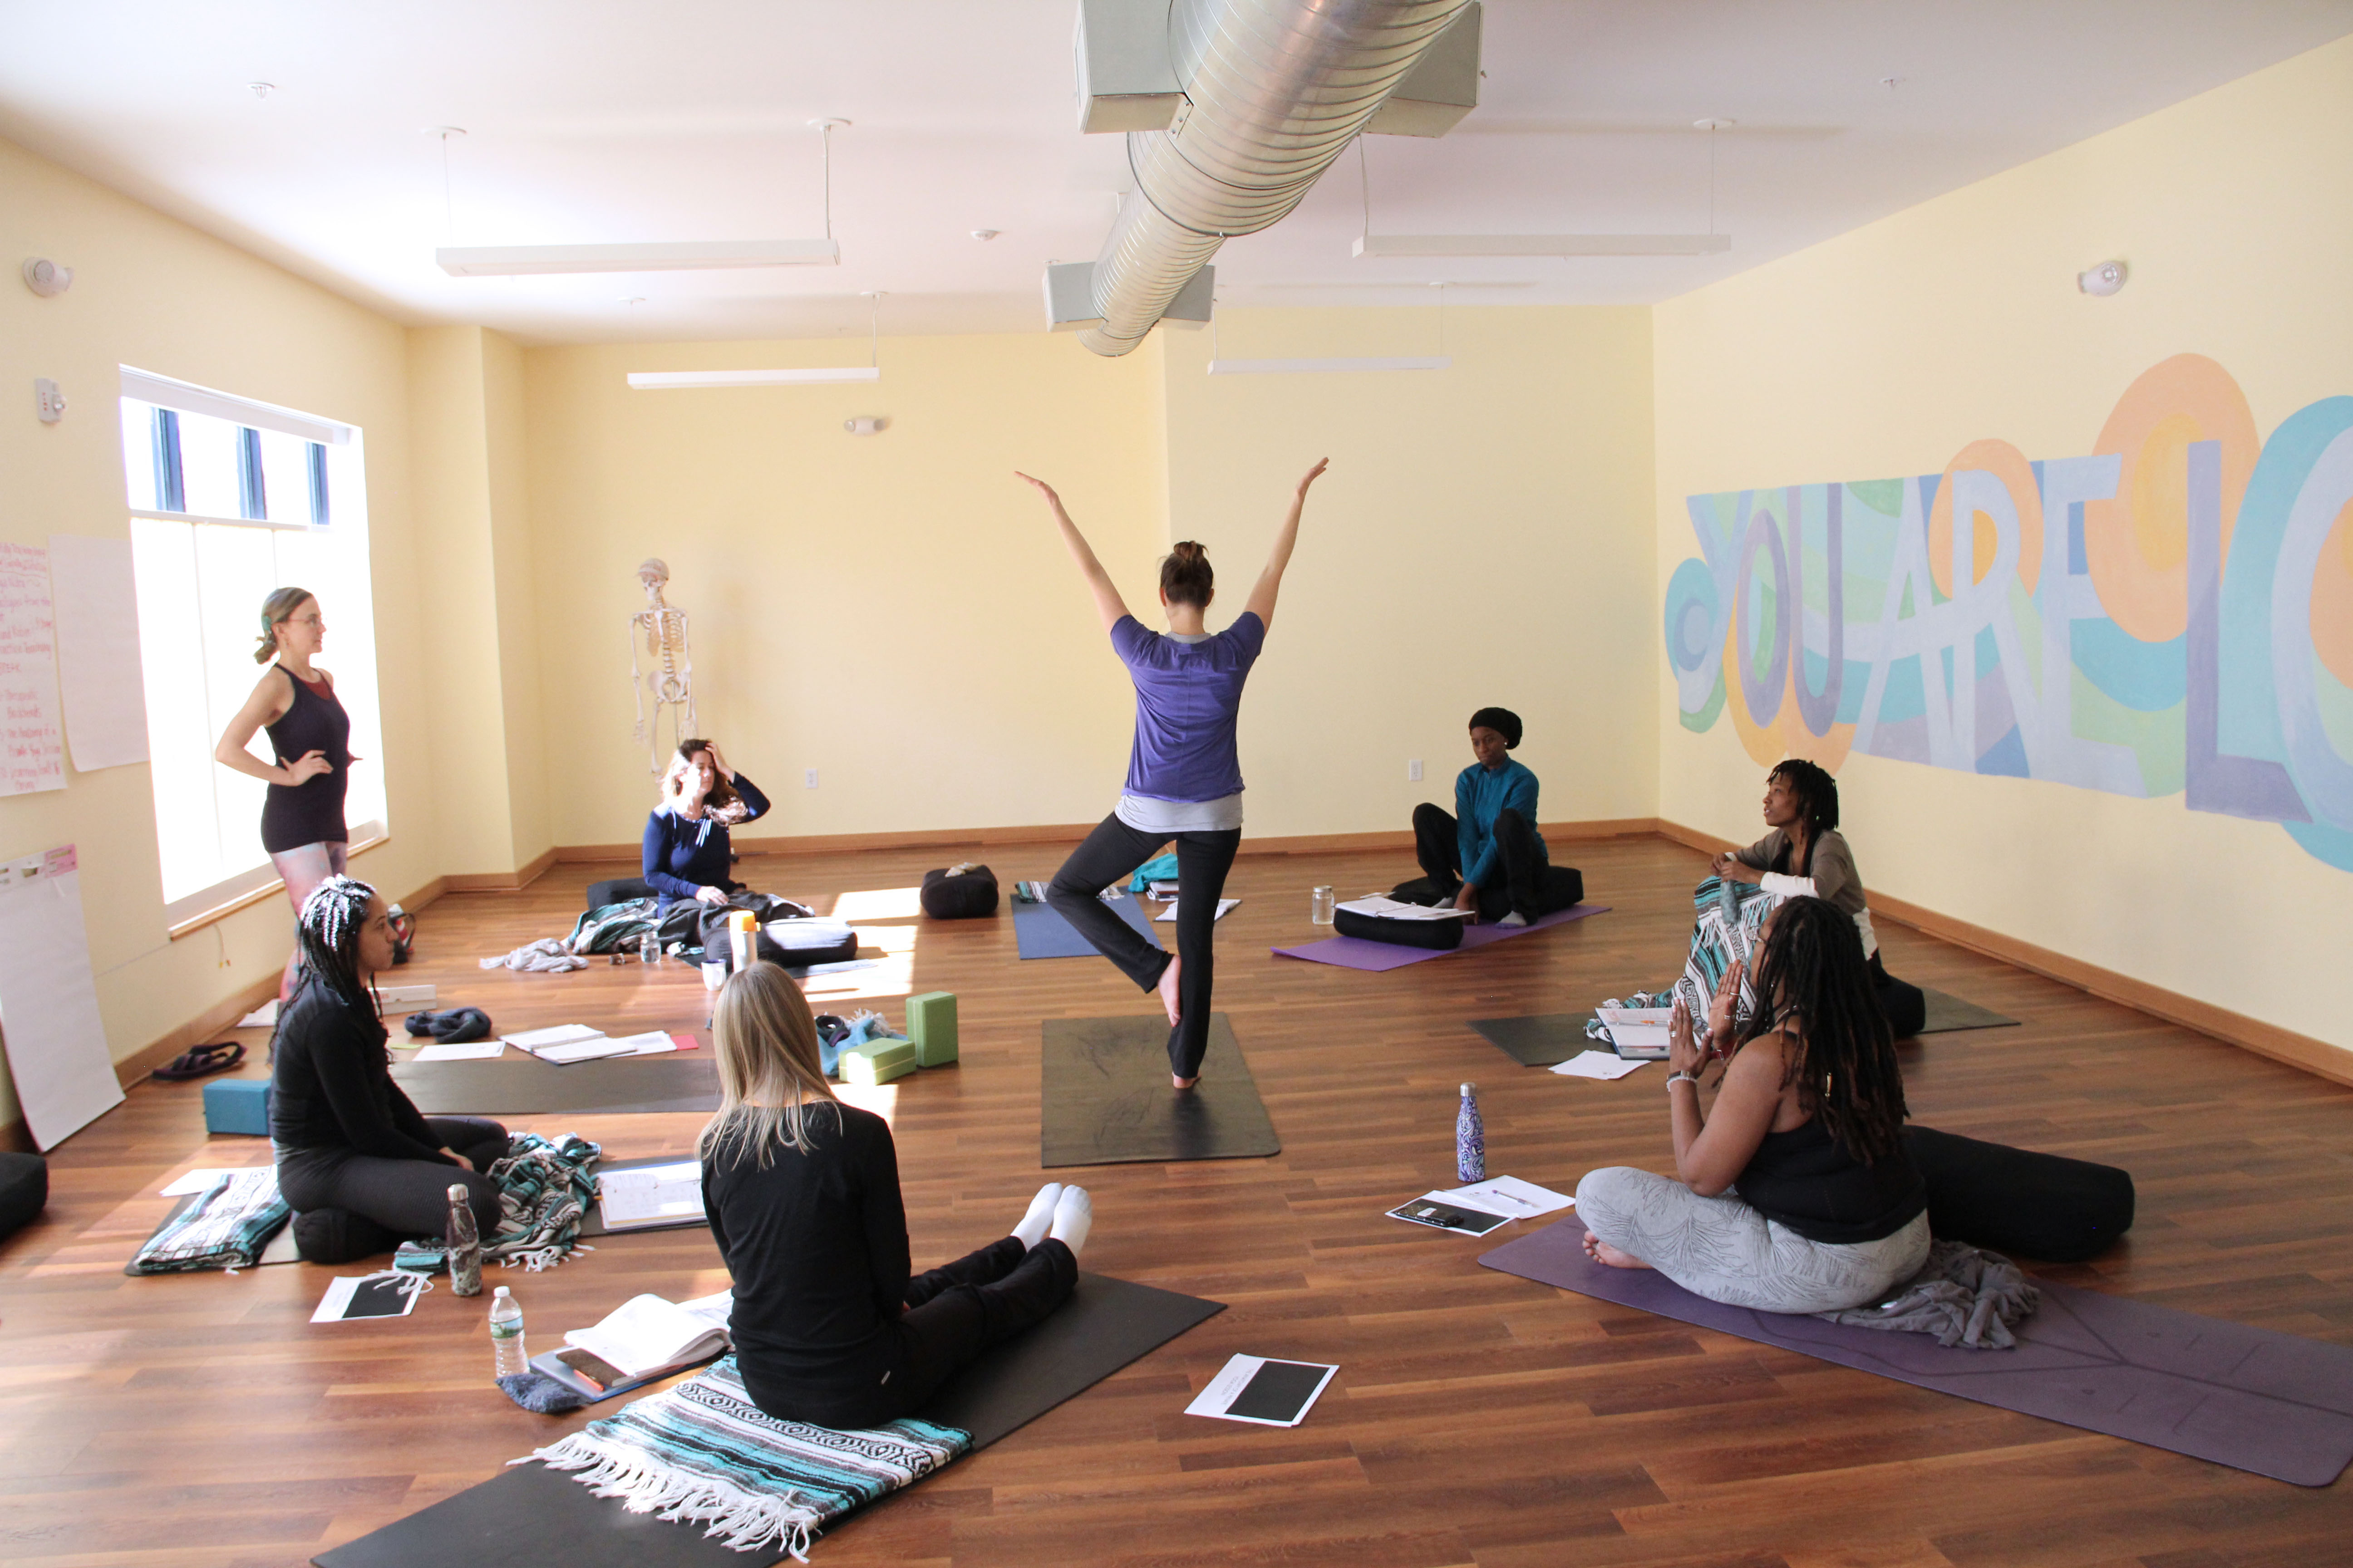
Please send completed applications to
karuna@4cornersyogawellness.com

Name:
Preferred Gender Pronouns:
Racial and Ethnic Identity:
Address:
Phone Number:
Email:

1. How long have you been practicing yoga? What kinds?

2. What are your gifts? What unique insights and assistance can you share with others as a result of your life experiences,
challenges and healing process?

4. How many days a week do you practice? What does it consist of (length of time, choice of asana)?

5. Have you taught yoga? For how long? In what capacity? Please list the dates, locations, levels, length of time for the class and the average class size.

6. Do you have a working knowledge of Anatomy/ Physiology/
Kinesiology?

7. Do you have any injuries?

8. What will be the most challenging and rewarding aspects of
teaching (or deepening your personal yoga practice)?

9. Please list the teachers you have studied with, for how long and what
they brought to your practice, as well as what challenged you about
their teaching. (Teacher, Length of Time, Gift, Challenge)

10. What are your intentions for taking this training? Please list specific goals.

11. What populations do you plan to focus on as a yoga teacher?

12. Please list any relevant volunteer or professional experience with social justice.

